First Part
1 Post Mauryan Period
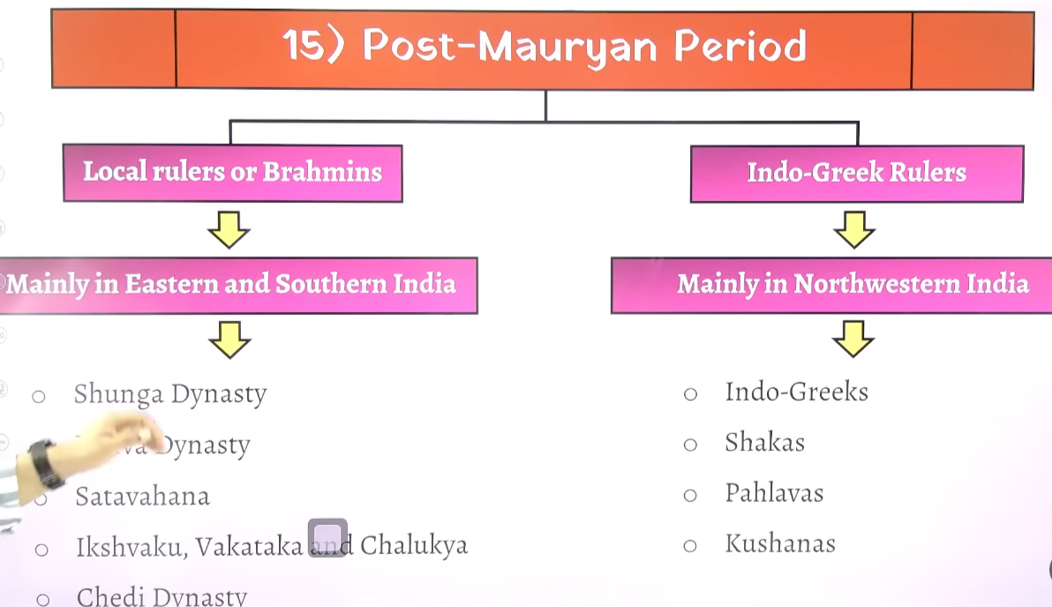

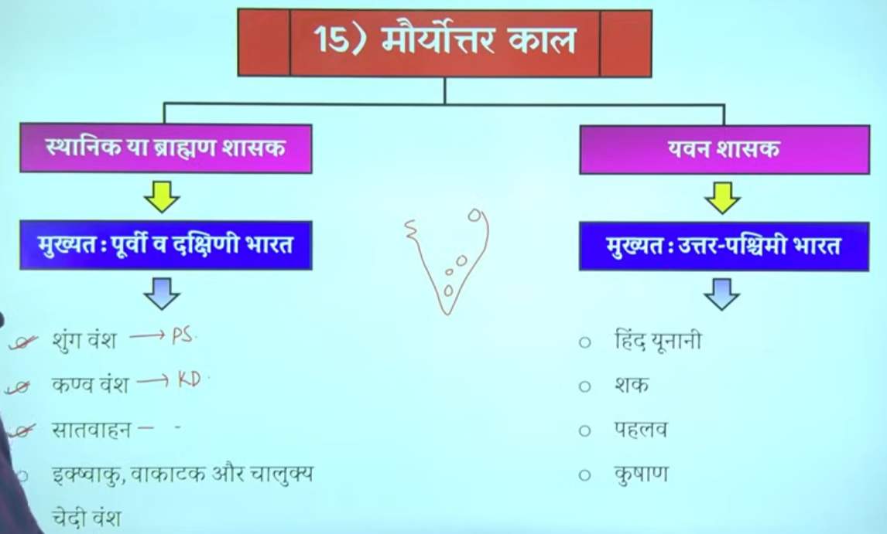

2

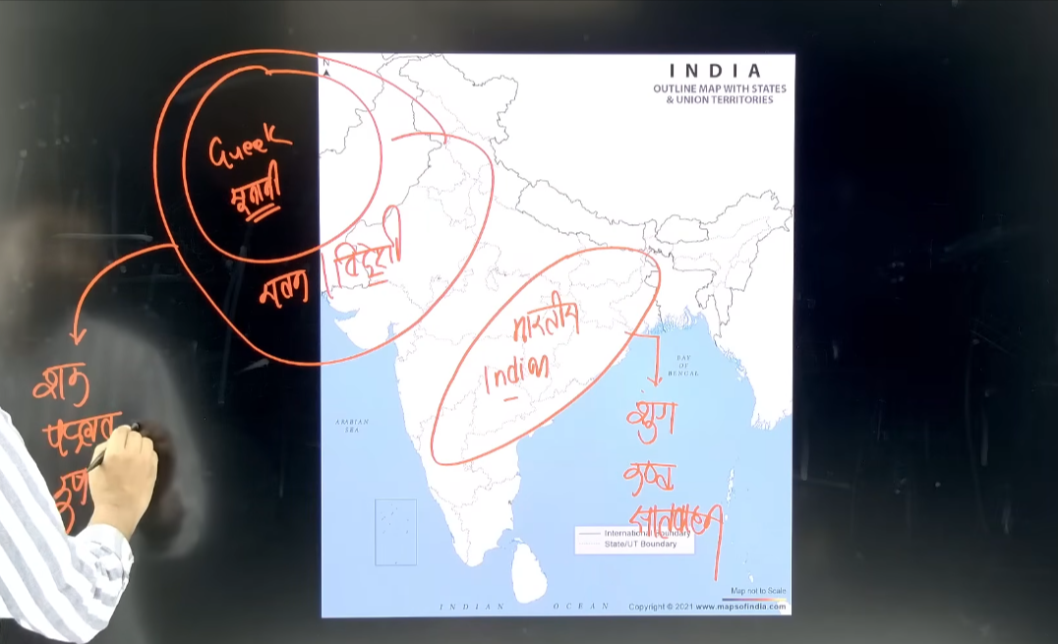

3
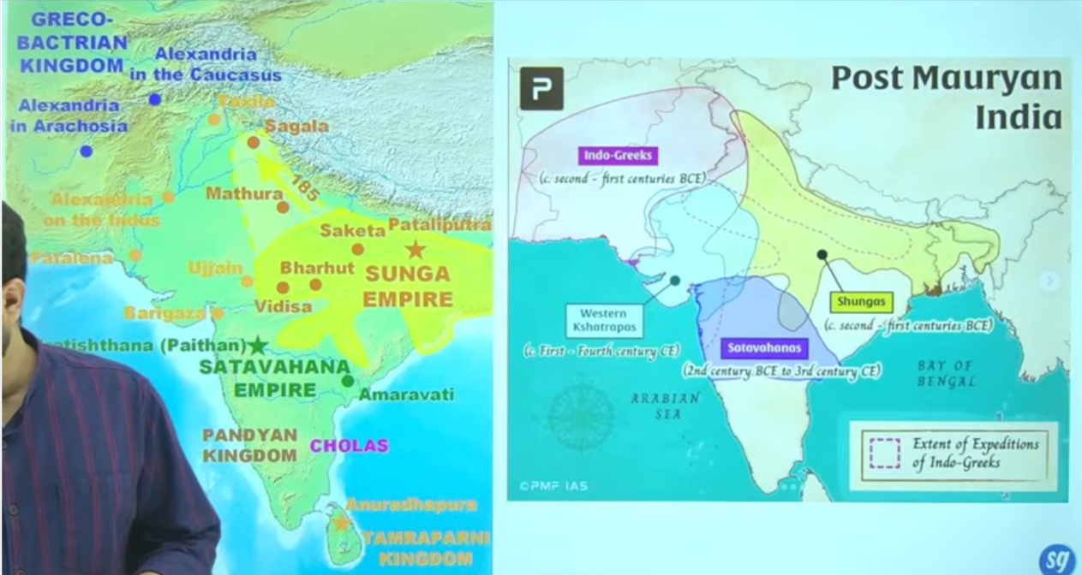

4 (unification & fragmentation)
In भारतीय राज्यों को ब्राह्मण राज्य (Brahmanical States) भी कहा गया है, विशेषकर मौर्योत्तर काल (Post-Mauryan Period) में।
इतिहास में एक सामान्य pattern देखा जाता है:
- शुरुआत में छोटे-छोटे राज्य (small states) बनते हैं।
- फिर कोई शक्तिशाली शासक आता है और इन राज्यों को जोड़कर एक विशाल साम्राज्य (empire) बनाता है।
- उसके बाद उसके उत्तराधिकारी (successors) कमजोर हो जाते हैं।
- परिणामस्वरूप, वह बड़ा साम्राज्य फिर से छोटे-छोटे राज्यों में टूट जाता है।
👉 इसी कारण एक समय पर कई अलग-अलग राज्य और वंश (dynasties) एक साथ दिखाई देते हैं।

🔁 भारतीय इतिहास में यह चक्र (Cycle)
- मौर्य साम्राज्य के बाद → छोटे-छोटे राज्य
- फिर गुप्त साम्राज्य आया → पुनः एकीकरण
- गुप्तों के पतन के बाद → फिर विखंडन
- फिर दिल्ली सल्तनत → पुनः एकीकरण
- उसके बाद विघटन
- फिर मुगल साम्राज्य → फिर से एकीकरण
- मुगलों के पतन के बाद → पुनः छोटे राज्य

🇮🇳 वर्तमान स्थिति
आज भारत में यह स्थिति नहीं है क्योंकि:
- हम एक लोकतांत्रिक (Democratic)
- और गणतांत्रिक (Republic) देश हैं
👉 इसलिए अब देश एकजुट (united) रहता है।

🔥 One Line (Exam Ready):
भारतीय इतिहास में बार-बार एकीकरण और विखंडन (unification & fragmentation) का चक्र देखने को मिलता है।

5 मौर्योत्तर काल (Post-Mauryan Period)
मौर्य साम्राज्य के पतन के बाद शासकों को दो भागों में बांटकर पढ़ा जाता है:
1️⃣ स्वदेशी (Indigenous) शासक
- भारतीय मूल के राजा indegenious king
- मुख्यतः पूर्वी और दक्षिणी भारत में शासन
- उदाहरण: सातवाहन (Satavahana)
2️⃣ विदेशी (Indo-Greek आदि) शासक
- विदेशी मूल के शासक
- मुख्यतः उत्तर-पश्चिम भारत में शासन
- उदाहरण: इंडो-ग्रीक

👑 सातवाहन वंश (Satavahana Dynasty)
- सातवाहनों ने लगभग 300–400 वर्षों तक शासन किया
- यह प्राचीन भारत का सबसे लंबे समय तक शासन करने वाला वंशों में से एक था
👉 तुलना:
- मौर्य वंश ने लगभग 200–250 वर्षों तक शासन किया
- इसलिए सातवाहनों का शासन अधिक लंबा माना जाता है
मौर्योत्तर काल में शासकों को स्वदेशी और विदेशी में बांटा जाता है, जिनमें सातवाहन सबसे लंबे समय तक शासन करने वाले वंशों में से एक थे।

6
"सातवाहन वंश ने लगभग 300–400 वर्षों तक शासन किया था। यह पहला ऐसा राजवंश माना जाता है जिसने इतने लंबे समय तक शासन किया। जबकि मौर्यों ने लगभग 200–250 वर्षों तक ही शासन किया था।
मौर्योत्तर काल (Post-Mauryan period) में भारत के पूर्व और दक्षिण भागों में भारतीय मूल के राजा शासन कर रहे थे, जबकि उसी समय उत्तर-पश्चिम भारत में इंडो-ग्रीक शासक शासन कर रहे थे।
शक (Scythians) भी इसी काल में भारत आए। उन्होंने भारत में पाँच अलग-अलग शाखाओं में शासन किया, जिन्हें ‘क्षत्रप’ कहा जाता था।
"After the decline of the Mauryan Empire, the largest empire in India broke into many small fragmented states.
Meanwhile, the north-western and central parts of India were ruled by foreign rulers such as the Indo-Greeks, Shakas (Scythians), Parthians, and Kushans.
Thus, in the north-western and western parts of India, Greek (Yavana) rulers established their rule.
The Satavahana Dynasty had two important capitals—Pratishthana and Amaravati.
The Shakas were divided into five different branches in India, and their rulers were known as ‘Kshatrapas’ (Satraps)."

7 Shatrap system
Shatrap introduced in india by Shakas Ruler
Satraps means:
👉 Provincial governors (state rulers) appointed to rule different regions of an empire on behalf of the king.
The Saka dynasty (Indo-Scythians) is generally credited with introducing and widely implementing the Satrap system of administration in India, starting around the 1st century BCE to 1st century CE.
"The credit for introducing the Kshatrapa (Satrap) system in India is generally given to the Persians, especially Darius I. However, Persian rulers had limited control and influence over Indian territories and did not rule extensively over large parts of India. Therefore, the actual implementation and widespread use of the Kshatrapa system in India is mainly credited to the Shakas, who applied it on a much larger scale."

While the Sakas popularized the system in India, it was Persian in origin
- Origin: The concept of Satraps originated in the Persian Achaemenid Empire (6th century BCE), where a "Satrap" was a provincial governor, or "protector of the kingdom" (khshathrapavan).4
- Satrap (Satrapal System): Originally a Persian system, a satrap is a governor of a province (satrapy) within an empire. It is a civil administration system where the satrap manages regional affairs, taxes, and security.
- Strategos (Military Governorship): A Greek term meaning "military general" or "military governor". This was introduced by the Indo-Greeks to specifically manage territories using military force

Strategos means:
Strategos introduced in india by indo Greek ruler
👉 A military general or commander, responsible for leading the army and sometimes governing a region.
Who introduced it?
👉 The term was first used by the ancient Greeks, especially in city-states like Athens, where strategos referred to elected military generals.

In summary, the Satrap system refers to a provincial administrative division, while the Strategos system refers specifically to military governorship; however, over time, a Satrap often functioned as a Strategos

Satrap = Civil/administrative ruler | Strategos = Military commander 👍

1. Satrap (सत्रप)
👉 English: Provincial governor appointed by the king to rule a region.
👉 Hindi: राजा द्वारा नियुक्त प्रांतीय शासक (राज्यपाल), जो किसी क्षेत्र का शासन करता था।
2. Strategos (स्ट्रेटेजोस)
👉 English: Military general or commander responsible for leading the army.
👉 Hindi: सेना का प्रमुख या सेनापति, जो सेना का नेतृत्व करता था।
👉 In later periods, especially in the Hellenistic kingdoms, Strategos sometimes performed both military and administrative functions, similar to Satraps. However, their primary role still remained military.
👉 बाद के काल में, विशेषकर हेलेनिस्टिक काल में, Strategos कभी-कभी सैन्य के साथ-साथ प्रशासनिक कार्य भी करने लगा, जो कुछ हद तक सत्रप जैसा था। लेकिन इसका मुख्य कार्य फिर भी सैन्य ही रहा।
👉 Strategos later = partly like Satrap, but mainly a military officer. 👍4
8

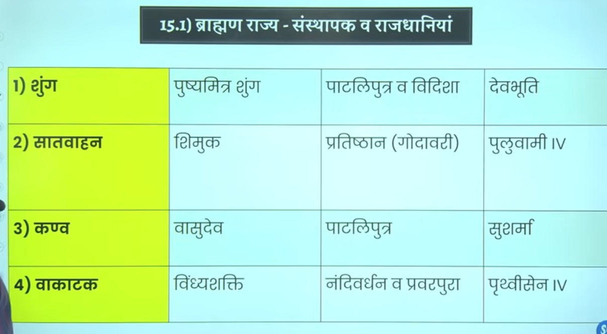

Shunga Dynasty Overview
The Shunga Dynasty ruled mainly over the regions of Magadha and parts of present-day Madhya Pradesh. There were two prominent rulers in this dynasty:
👉 Pushyamitra Shunga – the founder of the dynasty
👉 Agnimitra – the second important ruler
Agnimitra became famous because the great poet Kalidasa wrote a play called Malavikagnimitram, which describes the story of Malavika and Agnimitra in detail.

Religious Policy after Mauryan Period
After the Mauryan period, most of the indigenous (native) rulers followed Vedic/Brahmanical religion. However, this does not mean they disrespected other religions—they generally showed tolerance.
👉 Because of this, this period is often referred to as the “Brahmanical Revival” or “Brahmanical Age.”
👉 During this time, efforts were made to re-establish and revive Vedic traditions, removing earlier drawbacks and reorganizing the religion.
👉 When rulers adopted Vedic practices, it influenced the general population as well.

Origin and Gotra of Shungas
- According to Patanjali, the Shungas were Brahmins of the Bharadwaja gotra.
- According to Kalidasa, they belonged to the Kashyapa gotra.
- Their ancestors are believed to be from the region of Ujjain (Madhya Pradesh).

9 Shunga Dynasty (185 BCE – 73 BCE)

Ruled for about 112 years
2nd Centaury - 1st Centaury
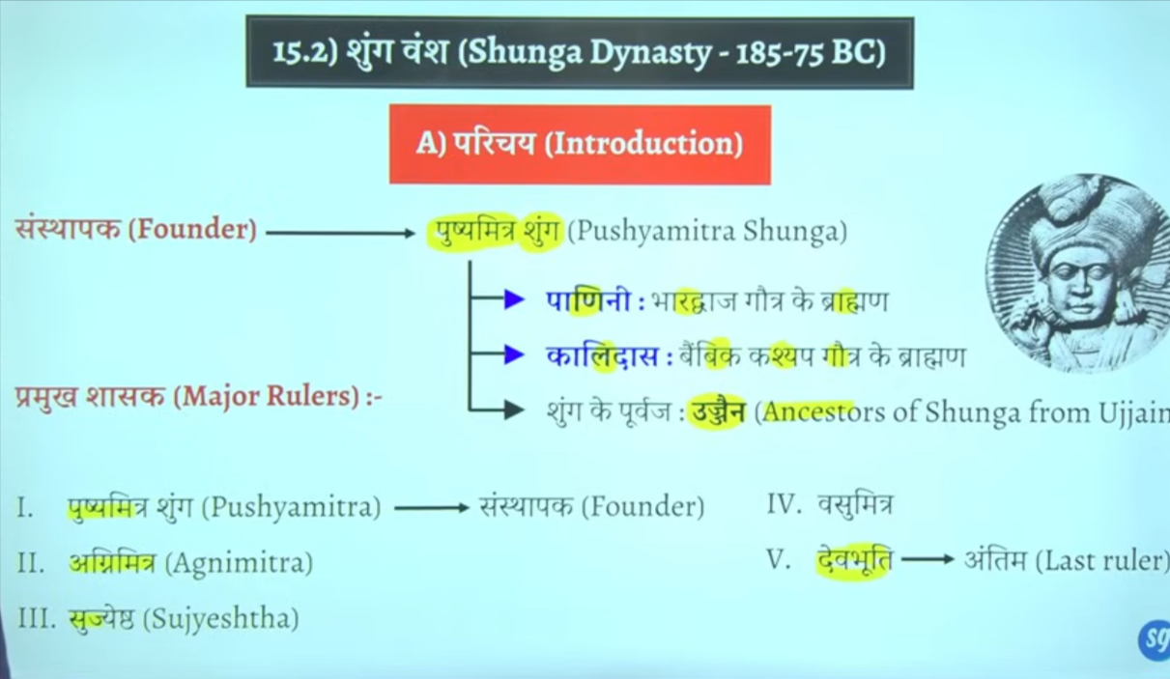

Capital-Patliputra later on shifted captial
Captial- Vidhisa Mp region
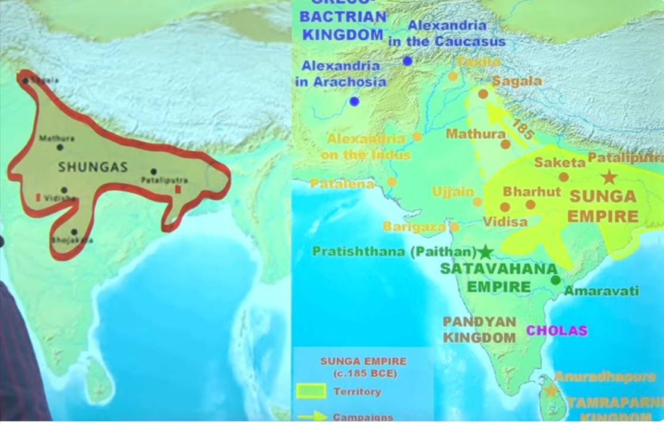

10 Pushyamitra shunga
"न केवल शुंगों ने, बल्कि सातवाहनों ने भी इसी प्रकार की उपाधियों का प्रयोग किया था, क्योंकि ये सभी वैदिक (ब्राह्मण) धर्म को मानने वाले थे। अपने शासनकाल में इन्होंने वैदिक धर्म की पुनः स्थापना करने का पूरा प्रयास किया।"

Even you can see that pushyamitra sungh ke purohit ka naam Patanjali tha
"तुम देख सकते हो कि पुष्यमित्र शुंग के पुरोहित का नाम पतंजलि था। पतंजलि ने अष्टाध्यायी पर महाभाष्य की रचना की थी। इन्हीं पुरोहित पतंजलि ने पुष्यमित्र से दो बार अश्वमेध यज्ञ भी करवाया था।"
अश्वमेध यज्ञ को यज्ञों का ‘राजा’ कहा जाता है। यह सबसे बड़ा यज्ञ था, जो राजनीतिक विस्तार political expansion and संप्रभुता (sovereignty) का प्रतीक माना जाता था। इस यज्ञ में एक घोड़ा छोड़ा जाता था, और वह जहाँ-जहाँ जाता, वह क्षेत्र उस राजा के अधीन माना जाता था।
इस यज्ञ के बाद सामान्यतः वह राजा ‘चक्रवर्ती सम्राट’ के रूप में जाना जाता था। इसलिए इस काल को वैदिक पुनर्जागरण (Vedic Revival) का काल कहा जाता है।"
"यह वही Menander (मिलिंद) है, जिसने Nagasena के साथ वाद-विवाद किया था। उनके प्रश्न–उत्तर पर आधारित एक पुस्तक लिखी गई, जिसका नाम Milinda Panha (मिलिंदपन्हो) है, जिसका अर्थ है ‘मिलिंद के प्रश्न’।"Book name minlindapahno Milind ke question
Sanchi Stupa👉 The railing of the Sanchi Stupa was originally made of mud/bricks, which was later replaced with stone.

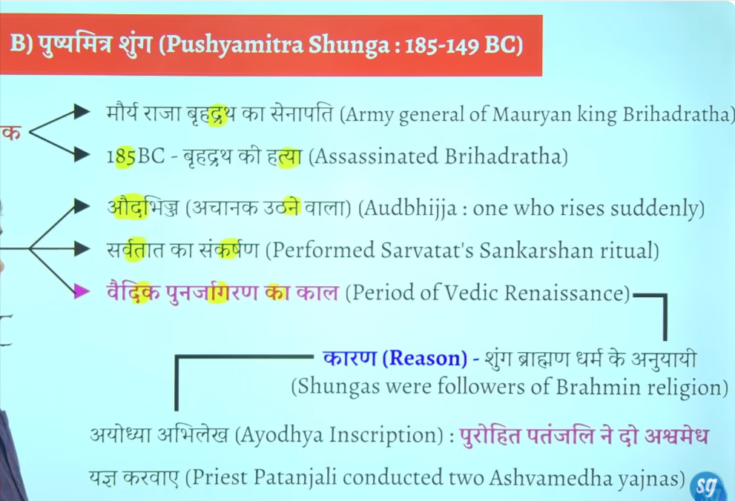

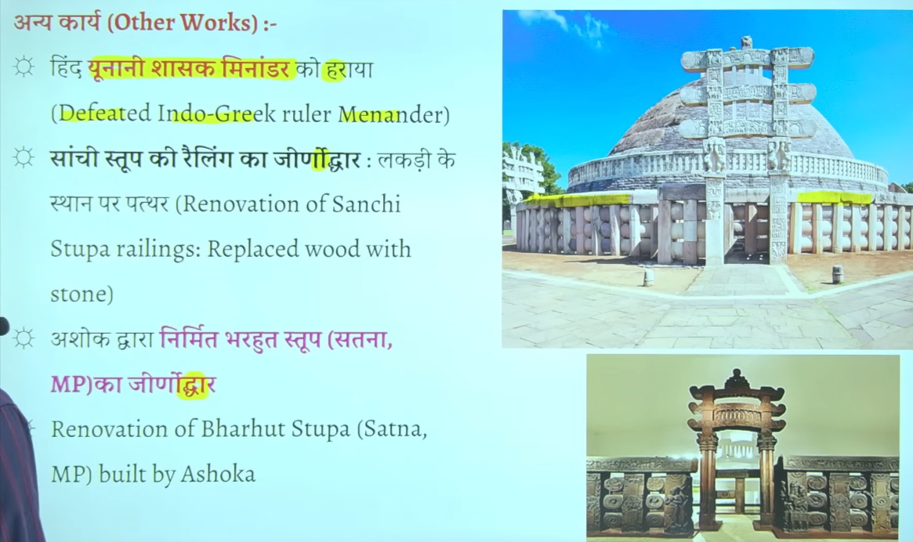

Shunga Dynasty
📅 Time Period
- c. 185 BCE – 73 BCE
- Founded after the fall of Mauryan Empire

👑 Founder
- Pushyamitra Shunga
- Was a Brahmin general of the Mauryas
- Killed last Mauryan ruler Brihadratha Maurya

🏛️ Capital
- Pataliputra (main capital)
- Vidisha (second important center)

⚔️ Political Features
- Faced Yavana (Indo-Greek) invasions
- Successfully defended kingdom
- Empire mainly in North & Central India

🕉️ Religion
- Followed Brahmanism (Vedic religion)
- Performed Ashvamedha Yajna
- Sometimes seen as revival of Brahmanical traditions

🏗️ Art & Architecture
- Development of Buddhist architecture continued
- Important sites:
  - Sanchi Stupa (expanded)
  - Bharhut Stupa

📜 Literature
- Period of Patanjali
- Work: Mahabhashya
- Mentions Yavana invasions

❌ Decline
- Last ruler: Devabhuti
- Killed by minister Vasudeva Kanva
- Led to rise of Kanva Dynasty

⭐ Important Facts
- Post-Mauryan Brahmanical dynasty
- Known for revival of Vedic practices
- Coexisted with Indo-Greeks

11 Agnimitra

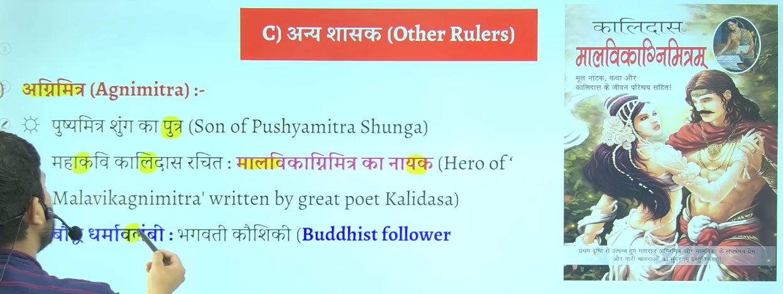
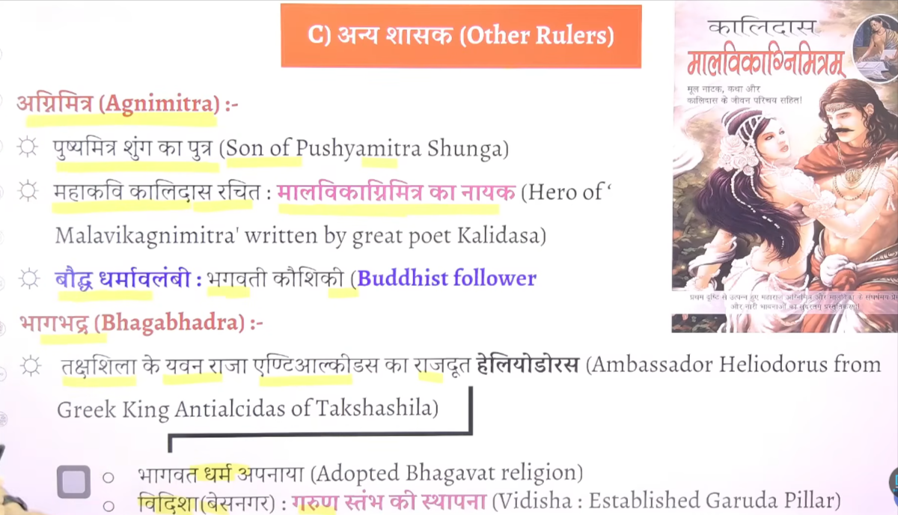

Agnimitra
- Second ruler of the Shunga Dynasty
- Son of Pushyamitra Shunga

🏛️ Position Before King
- Served as Viceroy (Governor) of Vidisha

⚔️ Political Achievement
- Fought a war with the Vidarbha kingdom
- Successfully established Shunga control over Vidarbha

📖 Literary Reference
- Mentioned in the famous Sanskrit play
👉 Malavikagnimitram by Kalidasa

⭐ Importance
- Shows political expansion of Shungas in Central India
- Known mainly through literary sources rather than inscriptions
Agnimitra, son of Pushyamitra, was the second Shunga ruler, known for the Vidarbha war and mention in Malavikagnimitram 👍

12 Bhagabhadra

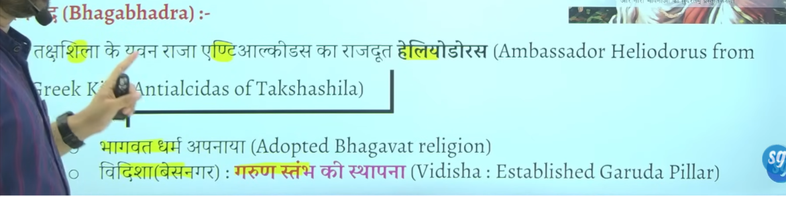

Bhagbhadra ke sahashan kaal me taksheeela ke ingogreek ruler antialciadas ke ambesador heliodoruosu inke shahsan kaal me ayay tha Vidisha ayaa tha
Jo ke bhavgvat dharm se influence hokar bhagvat dharm ko apnaya tha
Vidisha jisee basenagar kaaha jaat ahai inse wahah garin ishtam ko establish kyia tha

12 Devbhuti

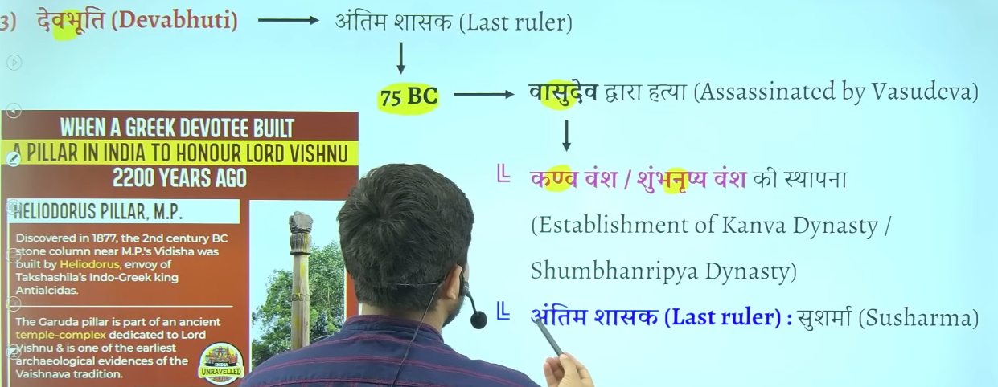

Kanva vansha j 10 20 saal he chaal kanva ka antim ruler shusharma hua jisko marka ke simuk ne sathvahan dynasty establish kyia tha

13 Shunga Dynasty – Rulers (with time)
- ⭐ Pushyamitra Shunga (c. 185–149 BCE)
- ⭐ Agnimitra (c. 149–141 BCE)
- Vasumitra (c. 141–131 BCE)
- Bhadraka (c. 131–124 BCE)
- Pulindaka (c. 124–122 BCE)
- Ghosha (c. 122–114 BCE)
- Vajramitra (c. 114–82 BCE)
- ⭐ Bhagabhadra (c. 82–75 BCE)
- ⭐ Devabhuti (c. 75–73 BCE)

14 Patanjali
👉 Patanjali was an important ancient Indian scholar known for grammar and philosophy.

📅 Time Period
- Around 2nd century BCE
- Generally associated with c. 150 BCE

👑 Dynasty / Ruler
- Belonged to the period of Shunga Dynasty
- Contemporary of Pushyamitra Shunga

📝 Major Work
- Mahabhashya (महाभाष्य)
  - A commentary on Panini’s Ashtadhyayi
  - Important text on Sanskrit grammar

⭐ Importance
- One of the greatest grammarians of ancient India
- Provides historical references of his time
- Mentions events like Yavana (Greek) invasions

❗ Note
- This Patanjali (grammarian) is different from Yoga Patanjali (Yoga Sutra author)

👉 One Line (Exam Ready):
Patanjali (c. 150 BCE), a scholar of the Shunga period, wrote Mahabhashya, a key work on Sanskrit grammar 👍

15 Shunga Dynasty – Sources of Information

📖 1. Literary Sources (साहित्यिक स्रोत)
- Kalidasa’s Malavikagnimitram
👉 Agnimitra और Shunga शासन की जानकारी देता है
- Patanjali – Mahabhashya
👉 Yavana आक्रमण और उस समय की स्थिति का वर्णन
- Puranas (पुराण)
👉 शुंग शासकों की सूची और वंशावली
- Buddhist Texts (Divyavadana)
👉 Pushyamitra के बारे में उल्लेख

🪨 2. Archaeological Sources (पुरातात्त्विक स्रोत)
- Bharhut Stupa inscriptions
👉 Shunga काल की कला और दान की जानकारी
- Sanchi Stupa
👉 Shunga काल में विस्तार और निर्माण कार्य

🪙 3. Numismatic Sources (सिक्के)
- Shunga काल के coins (सिक्के)
👉 शासकों और आर्थिक स्थिति की जानकारी

📚 Shunga Dynasty का उल्लेख किन पुराणों में है?
👉 शुंग वंश का उल्लेख कई पुराणों में मिलता है, जैसे:
- Vayu Purana
- Matsya Purana
- Brahmanda Purana
- Vishnu Purana
👉 इनमें शुंग शासकों की वंशावली (genealogy) और शासन का विवरण मिलता है

❓ Patanjali के Mahabhashya में Shunga का उल्लेख कैसे?
👉 सही है कि Patanjali का Mahabhashya मुख्यतः संस्कृत व्याकरण पर है
👉 लेकिन ध्यान दो 👇
- उस समय के उदाहरण (examples) देने के लिए
- Patanjali ने समकालीन घटनाओं (current events) का उपयोग किया
👉 जैसे:
- यवन (Indo-Greek) आक्रमण का उल्लेख
- उस समय की राजनीतिक स्थिति
👉 इसलिए indirectly हमें Shunga period की जानकारी मिलती है

🔥 Easy समझो
- Purana → Direct info (वंश और राजा)
- Mahabhashya → Indirect info (समकालीन घटनाएँ)

Shunga Dynasty is mentioned in Puranas directly, while Patanjali’s Mahabhashya gives indirect historical references through contemporary examples 👍

16 Pāṇini
👉 Panini Time Period:
- Around 5th–4th century BCE
👉 Dynasty / Period:
- He belonged to the pre-Mauryan period (before the Maurya Empire)
- Not tied to any specific dynasty, but lived during the time of Mahajanapadas
👉 Contemporary Rulers:
- He is generally considered contemporary to rulers of Gandhara region
- Sometimes linked with the time of Darius I (Persian rule influence in northwest India)
- Also placed around the time just before Chandragupta Maurya

One-line (revision):
👉 Pāṇini (5th–4th BCE) = Pre-Mauryan grammarian, contemporary to Gandhara rulers and around the time of Darius I. 👍
work and specilization
Here is a clear, short answer 👇
Panini – Work & Specialization
👉 Work:
- Author of Ashtadhyayi
- It is a systematic and scientific grammar of the Sanskrit language (about 4,000 rules)
👉 Specialization:
- Sanskrit Grammar (Vyakarana)
- Known for creating a highly structured and rule-based system of language analysis

One-line (revision):
👉 Panini = Father of Sanskrit Grammar | Author of Ashtadhyayi 👍

Second Part

Shunga dynasty

Ye gairchetryia shashak tha jati se brahman tha budha dharma ko sabse adhik nuksan pushyamitra shunga ne karway tha
Capital of shunga wans is vidhisa or patiliputra but main is mp me vidhisa ye patliputra se Rajdhani udhakar le gaya madhyapradesh kke vidhisa me
Ye buddha virohdi tha isme bahut sare buddha stupo ko nast karwa dyia tha but isne sanchi and barhut sitop ka punarnirman bhe Karwar tha

Usne bahut sare buddha stop ko tokar waha Sanskrit vidyaaly , mandir, ya gurukul jo use dekh laga usne wo banwaya tha jaha uskno nast karna thek laga usne nast karwa tha
Patanjali pushyamitra ke purohit the yani inke yaah jo bhe puja path hoga wo Patanjali karte the
Iske time per bahut sare granth likhe gae hai tojada tar granth pushyamitra ke time per he likhe gae hthe
Isne bahtu sare buddha vihar ka Nirman bhe karawa aur nast bhe kyai tha but jaydatar nast kyia tha
Ikse time per he buddhsit book jatak ka Nirman purja hua tha iske time per he Sanskrit book astadyaye ka Nirman hua tha iske timer per he manuistmiti likhe gae the

Astadyaee kisse sambhandit hai vyakarna se sambahndieth hai
Ye teeno pramukh book iske time per he likhe gae the

Gargi ne likha tha gargisamhita budah bikshuk ne likha jatak granth

Manusmirit bahut controversial book tha usme women and dalit ko uchit ishtan nahi dyai gaya hai

Jinsen ne harivasnh ke rachna ke to sabse Jayda book kiske tim per likhe gae to answer is pushymitr ashunga

Jb pushymitra shunga shanshn kar rahah tha tb magadh samrajya ka ant ho chuka tha cuki magadhsamrajya bahut he saktishali smarjay tha Ashoka bahut shaktishali tha uske succesoer bahtu weak the iska news agala bhagal ke Chetra me fail gayay tha jiske karan jo central asia and north west area ke indo Greek vedeshi rulers the unhone socha ke ku na magad per akraman kar de kuki magadh samrjaya to khtm ho chuka hai to fir Videsh se akraman hona fir se chalu ho gaya tha halaki apapa dehskte hai jb tk Mauryan dynasty the tb tk koi vedsehi akrmankari nahi ayaya tha
Chuki pushymitra shung ne bradhrth ko mara iske news pure bharat aur bharah bhe fail gae the to viedshi akrmankariyon ne socha ku na hum jakar pushymitra shung ko mar de

Pushymtir shung ke samay do vedhsie akramankari aye cuki wo madya asia central asia se aee the to unko yavan kahah jata tha
To pushmmitra suhung ke samay kitne akrman hue to do dono akraman yavan ne kyia tha aur pushyamitr ashunga ne dono ko hara dyia tha

Jaise isne harya iska varchasva bad gyay logo ne baola are bhaut shaktishali kiukisisne do vedehsi yvana akramankari ko parajeet kar dyai agal bagal me pushmita shung ke naam ka dahshat fail gaya tha
Pushmitra shung ne socha acha mauka hai patanjiali ko bulakar do ashvamedh yagay kar dyai
Chuki jb yavan akramankair ko harya tha to bharat ka chote mote raja aise he dar gaey the t o iske ashwamedh yagya ka horse ko chedna kisne ne ucht nahi samjha tha
Jitne bhar isne vedhesh ko harya utne baar isne aswmedh yagya karwaya tha
Do bar vedshi akrmankair aye aur dono bar shunga jeeta do aswamedh ygay karawa dono ke purohit the ptanjali

Pushyamitr ashung jeta tha apne beta ke wajah se iska bet atha agnimitra jo bhaut yogya tha yudh karke laut rahah tha aur ye fas gaya ek mahila ek prem me Malvika naam ke mahila the

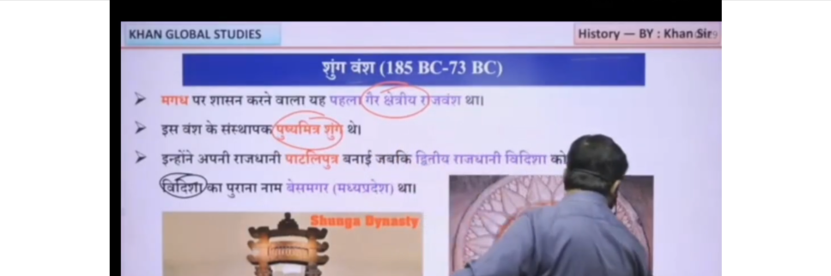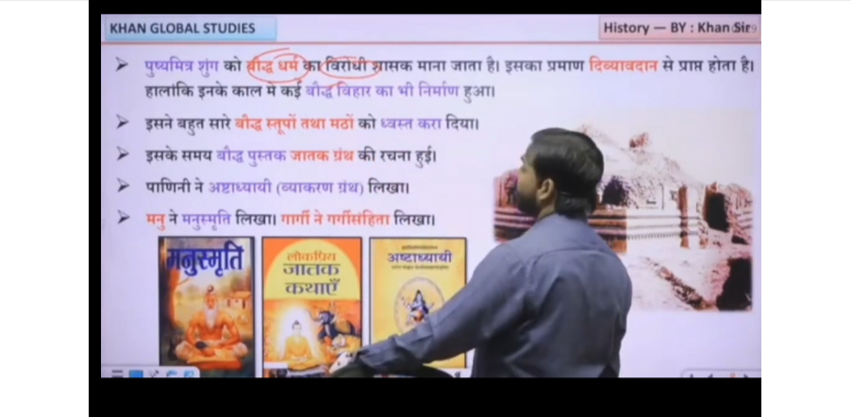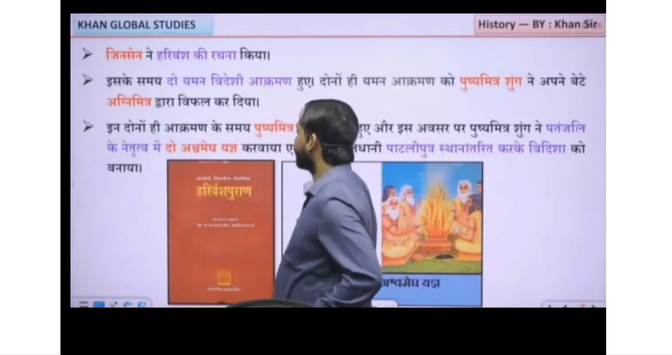

When the Shunga dynasty ruled Magadha (c. 185–73 BCE) after the fall of the Mauryas, India was politically fragmented and many regional dynasties and tribal powers ruled different parts of the subcontinent independently.
In the North-West, Indo-Greek rulers (like Menander later) controlled parts of Punjab and Gandhara, while Central Asian influence was increasing. In the North (other regions of Gangetic plains), several smaller republican or monarchical states existed, including remnants of old Mahajanapadas like Kuru-Panchala areas under local rulers. In the West India, regions like Malwa and Gujarat saw the rise of early local powers and Indo-Greek/Indo-Scythian influences later, with growing trade-based urban centers. In the South, powerful regional dynasties like the Satavahanas (Deccan region) emerged and expanded, controlling trade routes and acting as a major political force. Meanwhile, in the East (Kalinga/Odisha), the Mahameghavahana Chedi dynasty under Kharavela became prominent, restoring Kalinga’s power and expanding its influence.
Thus, during the Shunga period in Magadha, India was not unified but divided into multiple regional kingdoms and emerging dynasties, marking a strong phase of regionalization after Mauryan imperial decline.

